RTOS and Scheduling

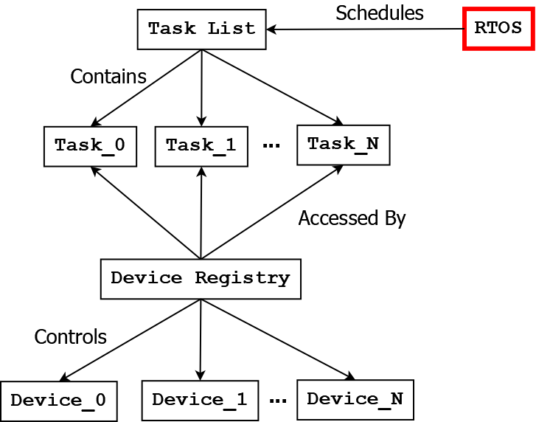

# RTOS

The RTOS class is the primary driver of the simulated real-time operating system that student-created tasks work within. It is not perfectly analogous to a true RTOS, and many simplifying assumptions have been made about the architecture in an attempt to make student development easier. However many of the same concepts touched upon in the classroom are applicable here.

# Task Scheduling

The RTOS presently works using a Round-Robin scheduling algorithm. During every frame the following actions are taken in order:

1. Read sensor data into their associated device registry float arrays.
2. Send new commands to the Ego vehicle’s actuators.
3. Extract the current task from the task list.
4. Execute the current task.
5. Prepare to load the next task.

Tasks are run according to the order they are placed in the task list. The time between each frame is 0.02 seconds, which means there are 50 frames within a second. Despite this constraint, students are still expected to create multiple tasks to solve each problem scenario – it is not allowed to define one “super-task” that handles all functionality.